**Urban Recovery**

**Mechanics:**

Player:

* Crouch/Sneak
  + Hide behind objects to avoid being spot by enemies
* Throw Items to distract enemies
* Pick up throwing items from stockpiles
* Take Damage when in cold for certain amount of time
* Decrease cold amount when near fire
* Instant death from enemy (shot)
* Open doors

Enemy:

* Patrol
* shoot if sees player
* Goes towards noises within hearing distance then return to patrol after a while
* Get dazed when hit by thrown brick or object

Person to Rescue:

* Follow Player
* Hide behind objects

**Visual Effects:**

Environment:

* Snow Falling
* Footsteps in Snow
  + Appearing and Disappearing
* Flickering Lights
* Fog
* Trash Fire

People:

* Breath

Other:

* Breaking of weapons

**Key Events**

* Start Game
  + Get a phone call or message that your friend has been captured
* Alleyway Maze
  + Enemy patrolling
* Gang Hideout
  + Apartment Building with gang members around (no one paying too much attention - only close proximity and noise will cause the enemies to notice the player)
  + Friend tied up in room
* End
  + Rescue friend and both successfully make it out of the hideout and back home

**Objectives/Challenges/Rewards**

* Objective: Rescue your friend
* Challenges: Being aware of enemies around you as well as staying warm
  + Figure out how to get past the enemies without the use of force
  + Get familiarized with the layout of the map so you can stay near the trash fires and out of the sight of enemies
* Reward: The feeling of accomplishment of beating the game and saving your friend from the clutches of the gang members

**Type of Progression**

* Non-Linear
  + Find your way to the gang hideout through small alleyways, while finding ways around the enemies
  + There will be several ways to make it to the end

**Flow**

* There will be several paths to take to get to the gang apartment and back

**Emotion**

* I want the game to have some tension as you make your way to the apartment and slightly chilly atmosphere.
  + There will be some relief from these emotions from the trash fires.

**Views/Focal Points**

* There will be areas of the map where the moon light will shine down and reflect off of the snow or water. And there will be places where there is building above you, while other places wont.
* Trash fires will attract the attention of the player due to their warm tones compared to the cooler colors of the environment. They will also stand out due to their light they provide.
  + I want the trash fires to provide the player with some relief of tension of the rest of the environment
* The gang apartment and friend’s apartment will have to stand out from the other apartments
  + One way will be an enemy in front of the door of the gang apartment
  + And both of the apartments will have a more saturated color than the others so they stand out

**Pickups/Health**

* There will be health, but there will be no pickups to restore your health (for now, if it is too hard, I will make the trash fire have an ability to heal the player)
* Health will be decreased due to cold, and all the health will be gone when the player is shot by an enemy

**Music/SFX**

* City sounds
* Footsteps/crunch of snow
* Slightly suspenseful background music

**Weather/Time**

* Slightly snowing
* 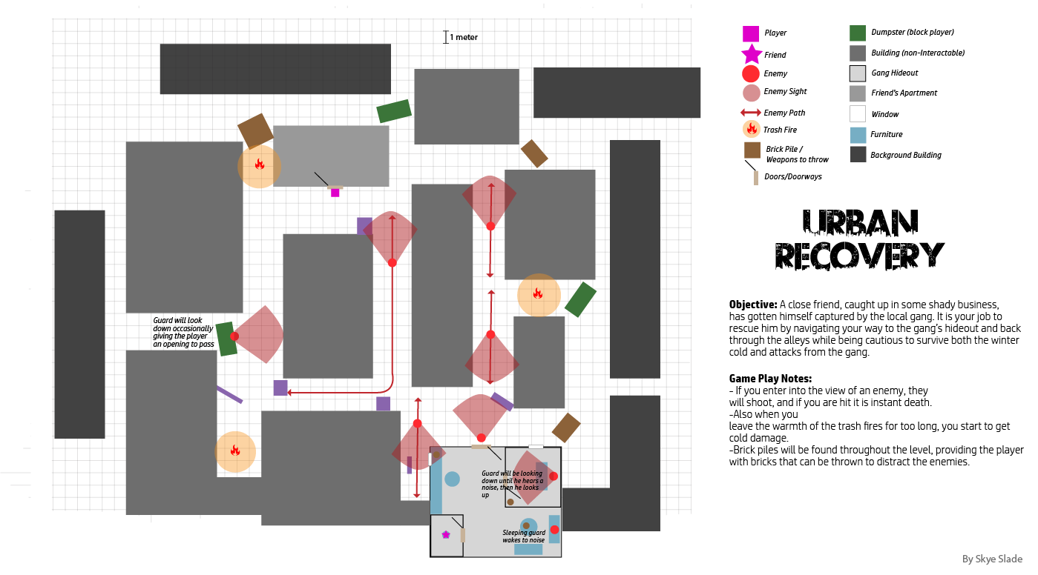Night – full moon providing the light